SNP Quality Analysis Tool

Technical description

For program version 3.2.3090.13120

Introduction 3
Program architecture 3
General description 3
The server side 4
The client side 5
The ClientObjects namespace 5
The DBObjects namespace 7
The ServiceObjects namespace 7
The GUI namespace 8
Design decisions 9
Data processing on the server 9
Open connections 9
Batchwise QC analysis of experiments 9
Synchronous vs. asynchronous database operations 10
Column formatting 10
Recalculation of sessions 10
Formatting of columns from result sets 10
Saving of user preferences 11
Control individuals 11
The configuration file 12
The connection file 13
Deployment 14
Server side 14
Client side 14

Introduction
SNP Quality Analysis Tool is a program for analyzing the quality of single nucleotide polymorphism (SNP) data. The purpose of the program is to perform different quality tests on a data set selected by the user, and to present the results from these tests so that the user can take actions such as discarding certain results or deciding to run certain samples again. The user is also able to interact with the quality tests in different ways, such as viewing the results which caused a test to fail or changing which tests should be done.

Program architecture

General description
The program is implemented as a client/server solution. On the server side is a Microsoft SQL Server 2005 database, but also code in the form of database stored procedures. On the client side is a C# program in the form of a single executable file which communicates with the database. The client can be configured using an XML-formatted configuration file which must be present in the same directory as the executable file.

Each client program can have many different open database connections at once. A database connection is opened as soon as the user selects to create a new session or load an existing session, and is ended when the user closes the session window. This means that each session in the client corresponds to exactly one database connection. The fact that each session has its own database connection means that SQL Servers temporary database can be used to store temporary data for each session, and as soon as a session is closed SQL Server automatically makes sure that the data vanishes. This technique saves a lot of communication between the server and the client, because information which is specific for a session still does not have to be stored at the client side. The client’s role is to open a new connection and create some temporary tables shared by the stored procedures when a session is started, and to close the connection when a session is ended.

The feature for comparison of data between different sources and the feature for identification of samples/individuals are the only two parts of the program which performs some more advanced operations on the client side.
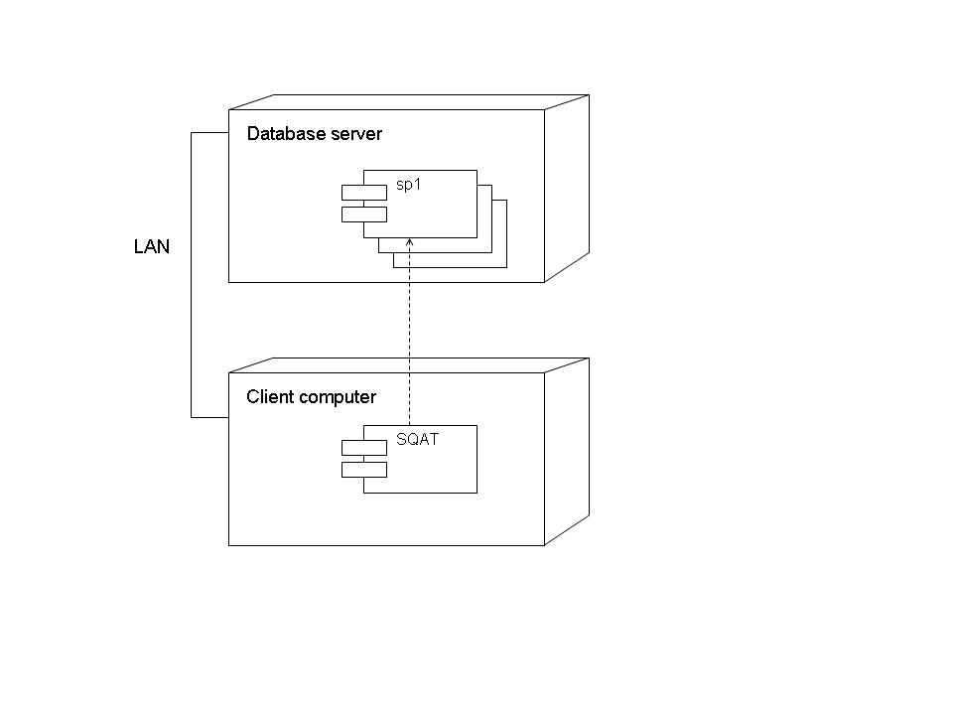
Figure 1 A combined deployment and component diagram showing how the client program SNP Quality Analysis Tool (SQAT) is dependent on several database stored procedures on the server side.

The server side
The server side of this program consists of 11 different stored procedures. Below follows a list of the stored procedures and what they do:

Stored procedure | Description
pSQAT_TestMarkers | This is the main stored procedure which performs the quality tests and generates the statistics tables shown in the client’s main window. The procedure is called by the client as soon as a new data set is opened or there has been any change in the currently open data set.
pSQAT_Approve | When the user approves a session, this procedure changes the status of valid genotype results to “approved” and locks the saved session it produces by changing the session’s type to one that does not respond to changes in the members of the working set.
pSQAT_GetControlStatistics | The procedure calculates certain statistics for a specific control item.
pSQAT_GetItemStatistics | This procedure calculates certain statistics for all samples or individuals but for a specific marker or assay.
pSQAT_GetGenotypeHistory | This procedure generates a history list for a certain genotype.
pSQAT_GetExperimentStatistics | The procedure calculates statistics for all markers or assays but for a specific sample or individual.
pSQAT_GetPlateContents | This procedure calculates statistics and generates plate position information for a certain plate. Note that data which belongs to the plate but is not included in the selected data set in the session is not included by this procedure either.
pSQAT_GetPlateSelection | This is a procedure which returns genotype results which will be affected when the user has selected certain wells, experiments and items for rejection in the client.
pSQAT_GetRerunItems | The procedure returns samples or individuals which fulfill certain given criteria. It is used for producing a list of items which need one more round of genotyping.
pSQAT_RejectMinority | To start with, this procedure finds all items with duplicate errors, but where there is a majority for a certain result (e.g. among the results A/C, A/A, A/C the result A/C is in majority with 67%). It then rejects the minority results for these situations. The percentage of majority required for the minority to be rejected can be sent to the procedure.
pSQAT_SubmitStatus | This procedure carries out the actual updates on genotypes which have had their status preliminary changed. This means that the status changes are “moved” from a temporary table to the real table.

The client side
The source code consists of a number of different helper classes, forms and user controls. The entry point for the executable is the Main function in the Starter class, where the configuration file and user preferences are loaded and the application is authenticated against the database (if that setting is turned on in the configuration file).

The ClientObjects namespace
This namespace contains helper classes which represent objects within the client program, such as different types of settings. The following table lists the different classes:

Class | Description
CIStringCollection | A collection of strings which is case insensitive in all comparisons and searches.
Comparison | The class represents and performs a comparison of data between different sources.
ComparisonHarmonizer | This class can harmonize the polarities between data from two different sources prior to a comparison.
ComparisonPrescanInfo | Harbors information about the scanning of two sources for common items and experiments before a comparison.
ComparisonReportGenerator | Generates a comparison report.
ComparisonSettings | Represents the settings which determine how a comparison should be made.
Configuration | Holds the settings which affect the whole program.
ExperimentQueue | Represents the queue of experiments which should be analyzed. A certain number of experiments are removed from the queue each time and sent for QC analysis until the queue is empty or the user aborts.
FilterIndicator | This class holds information about which types of selections the user has done when loading data, such as what kind of working sets that have been selected and what kind of selections have been made in the detailed filter.
FormattedColumn | Represents a list column with formatting codes in the column name as described in the section “Formatting of columns from result sets”.
GenotypeCollection | A collection of item/experiment combinations used in a comparison.
GenotypeDictionary | A dictionary containing unique item/experiment combinations as keys and genotype results as values.
GenotypeResultCollection | A collection of non-unique item/experiment combinations and genotype results.
GenotypeResultPairCollection | A collection of non-unique item/experiment combinations with two genotype results per combination.
Identification | This class represents and performs an identification of items (a matching based on the genotype results).
IdentificationPrescanInfo | Harbors information about the scanning of one source before an identification.
IdentificationReportGenerator | Generates an identification report.
IdentificationSettings | Represents the settings which determine how an identification should be made.
Investigation | This class is the base class for the corresponding comparison and investigation classes.
InvestigationReportGenerator | This class is the base class for the corresponding comparison and investigation classes.
InvestigationSourceInfo | This class is the base class for the corresponding comparison and investigation classes.
Preferences | Holds the settings which affect the whole program but are intended to be changed by each user individually.
ReportSettings | Represents settings for reports, such as what sections should be included in the report.
RerunSettings | Holds settings which specify rerun criteria for items. These settings only have effect in the form where rerun items are selected.
ResultTable | This class represents a matrix with items in one dimension and experiments in the other dimension, where the elements are genotype results.
SessionSettings | Holds the settings which are specific for each session.

The DBObjects namespace
In this namespace, classes are included to represent objects which persist in the database. All of these classes are very simple and do not contain much more than a name and ID number for the objects they represents. A diagram is shown to illustrate how the classes are related to each other.

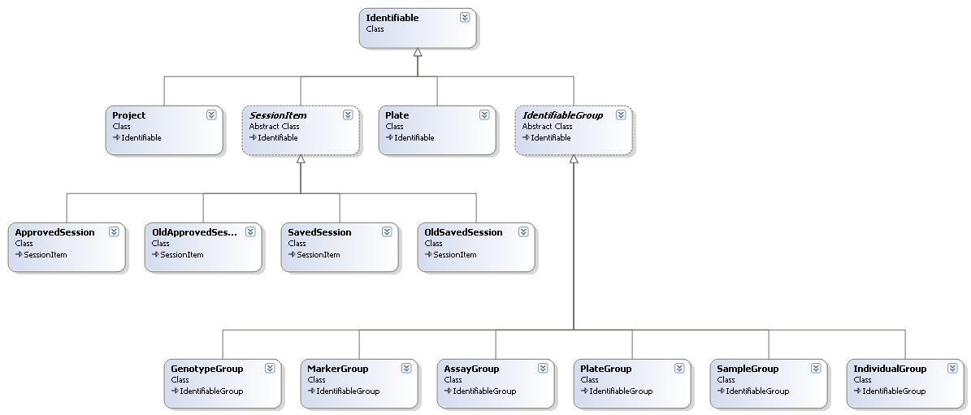

For some of the classes there are also typed collection classes available.

The ServiceObjects namespace
The classes in the ServiceObjects namespace are classes which perform certain actions. Some have the role of smaller helper classes, whereas others, such as the DataServer class, are big and important parts of the program. The following table describes the classes:

Class | Description
DataServer | A very important class which performs all of the database communication and holds the database connection which represents a session in the database. It also contains some static methods to perform database operations outside of a certain session.
FileServer | Contains methods used for reading and writing tab delimited text files from and to disk.
GenotypeFetcher | A helper class for retrieving genotype results in a structured manner.
MessageManager | Takes care of displaying warnings and error messages.
ObjectServer | This class is like a layer on top of the DataServer class. It contains methods for retrieving information in form of objects from the DBObjects namespace.
ReportGenerator | Generates reports and writes the to disk.
TabDelimiter | This is a small helper class for generating tab delimited text.

The GUI namespace
This is the namespace for the forms and user controls. Some of the forms are general in nature and are used in different places throughout the program. The diagram below shows how some of these reusable forms are connected.

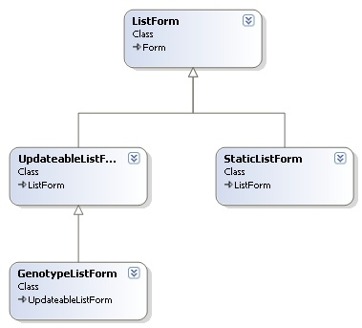

In the following table, the function of the four user controls is described.

User control | Description
AdvancedCheckedListBox2 | This control is a list box with a label showing the number of items and number of checked items in the list. It also has a menu for performing various actions on the list, such as checking/unchecking items, copying items etc.
AdvancedListView2 | This is a list in detail mode with a label showing the number of items and number of selected items in the list. It also has a menu for performing various actions on the list, such as selecting all items, copying items etc.
ComparisonSource | The control represents a source selection for comparisons between different sources.
PlateGrid | The PlateGrid control is a physical representation of a plate with wells/cells that can contain an object. It also has functions for selecting wells/cells with the mouse.

Note that there is also a component called GridlineListView which is a ListView containing a workaround for making gridlines display correctly when the list is scrolled (which comes from a confirmed bug in the .NET ListView control).

Design decisions

Data processing on the server
All data processing except when comparing data between different sources is performed on the server. The reasons are:
- Only the server needs to be fast and have a lot of memory.
- It potentially reduces the amount of data sent over the network.
- Well-suited for very large data sets.
- Some of the operations can be done efficiently using set based SQL operations (such as the duplicate tests).
- Changes can be made to the stored procedures without having to redistribute the client program to the users.

The drawbacks are:
- When many users are working at the same time, it would be more efficient to spread the work on the client machines.
- Some data processing is not well suited for set based SQL operations (such as the inheritance test).
- The T-SQL code is more difficult to understand and maintain than object orientated code.

Open connections
When a user opens a session, the database connection stays open during the whole lifetime of the session. The reason for this is:
- Keeping an open connection makes it possible to store information specific to the session in temporary tables.

The drawback is:
- If many users are working at the same time, the database server may have trouble maintaining all open connections.

Batchwise QC analysis of experiments
When a data set is opened, the client program arranges a queue of all the experiments in the data set. These experiments are then analyzed for example 100 at a time until the queue is empty. (The batch size is possible to set in the configuration file.) The benefits are the following:
- Analyzing small batches of the whole data set at a time avoids blocking of the database server, since different sessions are allowed to come in between the gaps of the batches.

- Each batch does not contain much data, so any part of the analysis for which the execution time depends heavily on the amount of data will execute faster.

The drawback is:
- There will be more roundtrips to the server.

Synchronous vs. asynchronous database operations
There are only a few calls to the database which are asynchronous, such as the fetching of items and experiments in the detailed filter selection and, most importantly, the execution of the main test procedure pSQAT_TestMarkers. More operations could have been asynchronous, but were kept synchronous for simplicity reasons.

Column formatting
All column names and formatting directions for data tables are set in the select statement when fetching result sets from the database (see “Formatting of columns from result sets”). The reason for this is:
- The look of one data table is controlled in one place only.
The drawbacks are:
- The formatting code is a custom-made invention.

Recalculation of sessions
As soon as any change has been performed in a session (such as the rejection of a genotype or the changing of a setting), all of the statistics is recalculated from scratch by calling the pSQAT_TestMarkers procedure. The reason is that:
- Any attempt to update only the part of the statistics which should be affected by the change will make the program more error prone and difficult to maintain.
The drawback is:
- Constant recalculation of the statistics can be tedious for the user (this is solved by having a preference setting determine if the recalculation should be done automatically or manually).

Formatting of columns from result sets
When a result set is “returned” by a stored procedure, the formatting code (if there is one) is contained in the names of the columns. When the DataServer class on the client side receives the result set, the formatting code is moved to the ExtendedProperties property of each DataColumn. The formatting code is then interpreted by the AdvancedListView user control when the DataTable is about to be displayed.

Each formatting code starts with “//” followed by two characters. Here is a list of the codes and what they mean:

Column formatting code | Meaning
//IN | “Integer – Normal”. The column contains integer values.
//IF | “Integer – Failure”. The column contains integer values and should be indicated by a red color when greater than zero.
//RN | “Real – Normal”. The column contains decimal values.
//RF | “Real – Failure”. The column contains decimal values and should be indicated by a red color when greater than zero.
//PN | “Percent – Normal”. The column contains fractions which should be displayed as percent.
//PF | “Percent – Failure”. The column contains fractions which should be displayed as percent, and indicated by a red color when greater than zero.
//CN | “Character – Normal”. The column contains text.
//CF | “Character – Failure”. The column contains text and should be indicated by a red color when the word “Failed” is used.

The formatting code “//CN” is equivalent to having no formatting code at all.

Saving of user preferences
When the user changes the preference settings, the settings are saved in isolated storage (as provided by the .NET framework) using the filename SQATPreferences.obj. This is accomplished by calling the Serialize method of the Preferences class.

Control individuals
Three types of controls are recognized by the program. When an individual is a control, it means that a certain test is performed on the genotypes from the individual, and that the results from the controls are kept separately from the results of ordinary samples or individuals. Which test that is performed on the control depends on which control group it belongs to. The following table lists the control groups:

Control group | Description
Blank controls | Results from these controls are considered to have passed the test when they have no genotype call (N/A).
Homozygote controls | Results from the homozygote control items are considered to have passed the test when they have a homozygote genotype. Only results with a genotype call are tested.
Inheritance controls | Results from the controls are considered to have passed the test when all results from the family are consistent with the inheritance pattern. Only results which have a genotype call and have not failed the duplicate test are included in the inheritance test.

The control groups are implemented as a property (column) of the individual. Individuals which are not controls have the property set to “Genotyping”.

The configuration file
The client program can be configured using the configuration file SQATconfig.xml, which must be present in the same directory as the client executable file. Below follows a table of the setting key names, the allowed values and a description for each setting.

Key | Allowed values | Description
isolationlevel | read uncommitted  read committed  repeatable read  serializable | Sets the isolation level for the SQL Server connections, i.e. how well isolated the transactions should be from other transactions.
versioncontrolflag | true  false | Determines whether the client program will refuse to start if the client’s version number is not listed in the database.
allowunlockflag | true  false | Determines whether the user can unlock approved sessions from the “Open Session” window. When set to false, the context menu alternative for unlocking approved sessions will not be shown.
asynctimeout | An integer in the interval [0 , 2147 483 647] | Sets the command timeout in seconds for asynchronous database operations.
synctimeout | An integer in the interval [0 , 2147 483 647] | Sets the command timeout in seconds for synchronous database operations.
experimentbatchsize | An integer in the interval [0 , 2147 483 647] | Determines the number of experiments which will be analyzed in each batch during the QC analysis.
listrowlimit | An integer in the interval [0 , 2147 483 647] (bound also by the number of rows that can actually be displayed by the ListView control). | Sets the limit for how many rows it should be possible to display in a list view.
Listcolumnlimit | An integer in the interval [0 , 2147 483 647] (bound also by the number of columns that can actually be displayed by the ListView control) | Sets the limit for how many columns it should be possible to display in a list view.

The key-value pairs are listed using the following XML syntax:

<Configuration>
<Item>
<Key>isolationlevel</Key>
<Value>read committed</Value>
</Item>
<Item>
<Key>versioncontrolflag</Key>
<Value>true</Value>
.
.
.
</Configuration>

The connection file
Another file which must be present in the same directory as the client executable file is the SQATconnect.xml file. This file lists all possible database connections which the user can choose from, and their respective connection strings. If the file contains only one connection, the program automatically starts with that connection. When more than one connection is listed in the file, the user is prompted to select which connection to use.

The database connection strings are listed using the following XML syntax:

<Connections>
<Connection>
<Name>MyConnectionName1</Name>
<ConnectionString>data source=MyServer;integrated security=true;initial catalog=MyDatabase1;</ConnectionString>
</Connection>
<Connection>
<Name>MyConnectionName2</Name>
<ConnectionString>data source=MyServer;integrated security=true;initial catalog=MyDatabase2;</ConnectionString>
</Connection>
.
.
.
</Connections>

Deployment
The following steps must be taken when setting up the system.

Server side
- Installing SQL Server 2005.
- Creating the database.
- Creating the tables in the database.
- Creating the triggers, views, functions and stored procedures.
- Allowing the users read/write access to the database and setting execution rights for the functions and stored procedures.
- Storing the login names and full names of the users in the authority table.
- Optionally storing the name of the program and the current version number in the application_version table, if version control is going to be used.
- Optionally storing reference data sets in the reference_genotype/reference_set database tables, if comparisons to a reference set should be made.

Client side
- Setting the proper configuration in the SQATconfig.xml file.
- Listing the database connection(s) in the SQATconnect.xml file.
- Copy the SQATconfig.xml, SQATconnect.xml and SNP Quality Analysis Tool.exe files to the appropriate directory on the client machine(s).

